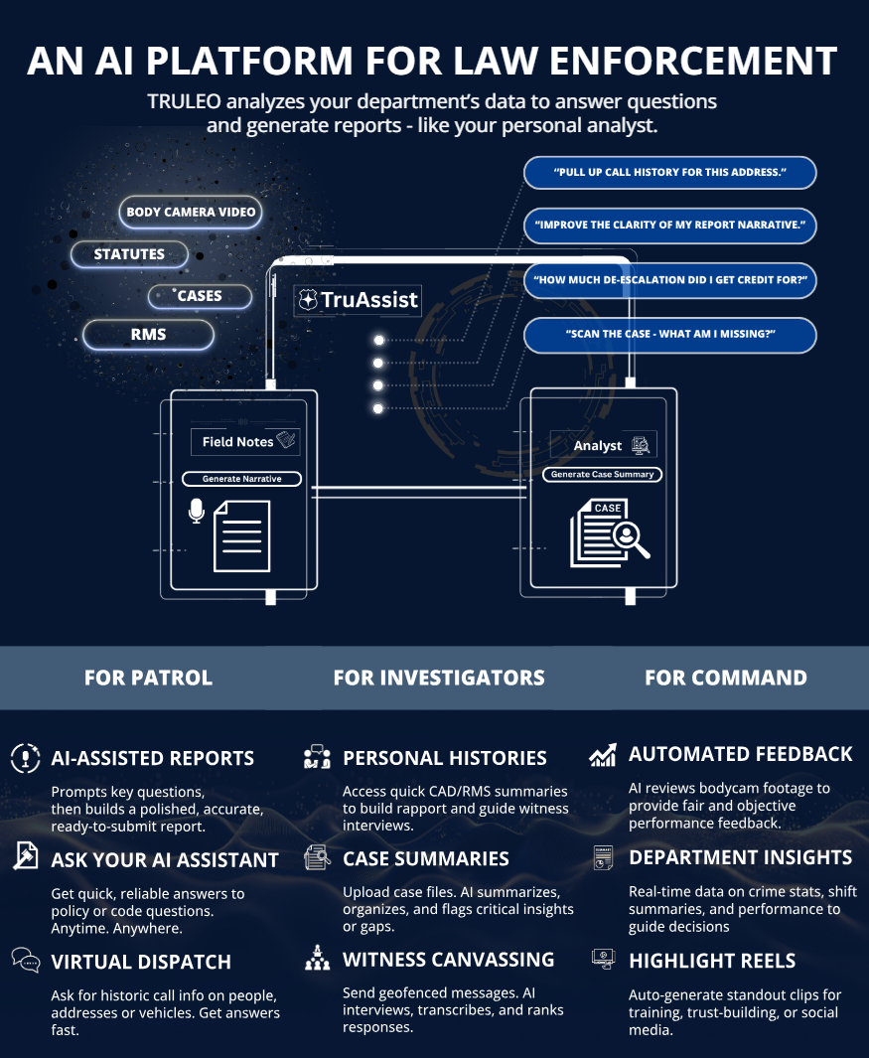
TRULEO END USER LICENSE AGREEMENT
This TRULEO End User License Agreement (this “Agreement”) is by and between TRULEO, Inc., a Delaware corporation (“TRULEO”), and the entity identified on the signature page (“Department”), on the date signed below. TRULEO and Department may be referred to herein collectively as the “Parties” or individually as a “Party.”
The Parties agree as follows:
1. Definitions. The term “Authorized User” means an employee or contractor of the Department who the Department permits to access and use the Platform according to the Department’s license hereunder. The term “Platform” means the FBI CJIS cloud applications described in Appendix A.
2. License. The Term of this Agreement is outlined in Appendix B
(a) License Grant. During the Term, and subject to and conditioned on the Department’s payment of Fees if applicable, and compliance with all other terms and conditions of this Agreement, TRULEO grants the Department a non-exclusive, non-sublicensable, and non-transferable license. PLATFORM IS LICENSED TO THE DEPARTMENT, NOT SOLD.
(b) Use Restrictions. The department shall not use the Platform for any purposes beyond the scope of the license granted in this Agreement or for any purpose that infringes, misappropriates, or otherwise violates any intellectual property right or other right of any person or that violates any applicable law.
(c) Delivery Process and Obligations. The Department shall, on or before the start of the Term, deliver credentials to TRULEO to securely access the Department’s policies, records management system and or body-worn camera video storage environment. Secure access shall be continuous during the Term. TRULEO shall host the Platform on AWS Gov Cloud infrastructure and the Platform shall be deemed to have been accepted by the Department thirty (30) days after the start of the Term unless before such date The Department has provided TRULEO written notice containing reasonable details of non-conformity.
(d) . Maintenance and Support This Agreement entitles the Department to maintenance and support described in Appendix C.
3. Department Responsibilities.
(a) General. Department is responsible and liable for all uses of the Platform resulting from access provided by the Department, directly or indirectly, whether such access or use is permitted by or in violation of this Agreement.
(b) Access to Policies, RMS and Body Camera Videos. The Department is solely responsible for providing access to the Department’s policies, records management system (RMS) and body camera video storage environment. The Department acknowledges the policies, records and videos belong to the department and will instruct their vendors to fully cooperate with TRULEO to gain access to the department’s data. THE DEPARTMENT’S INABILITY TO PROVIDE ACCESS TO TRULEO SHALL NOT AFFECT THE DEPARTMENT OBLIGATIONS TO FULFILL ALL OBLIGATIONS UNDER THIS AGREEMENT, INCLUDING WITHOUT LIMITATION PAYMENT OF ALL FEES AND OTHER AMOUNTS DUE.

4. Fees, Payment. The department shall pay TRULEO the fees (“Fees”) outlined in Appendix B on or before the due date. If Department fails to make any payment when due, in addition to all other remedies that may be available: (i) TRULEO may charge the Department a late fee of $250 per day until full payment is received, (ii) Department shall reimburse TRULEO for all reasonable costs incurred by TRULEO in collecting any late payments, late fees or interest, including attorneys’ fees, court costs, and collection agency fees; and (iii) if such failure continues for thirty (30) days, TRULEO may (i) suspend or prohibit access to the Platform and/or (ii) terminate this Agreement by written notice. All Fees and other amounts payable by the Department under this Agreement are exclusive of taxes. ALL FEES PAID ARE NON-REFUNDABLE.
5. Term and Termination.
(a) Term. The term and the renewal term(s) of this Agreement are outlined in Appendix B (the “Term”) unless terminated earlier according to any of the Agreement’s express provisions.
(b) Termination. Either Party may terminate this Agreement by written notice if the other Party materially breaches this Agreement and the breaching Party fails to cure the breach within sixty (60) days after the non-breaching Party provides written notice of such breach.
(c) Effect of Expiration of Termination. Upon expiration or earlier termination of this Agreement, the license granted hereunder will also terminate. NO TERMINATION WILL ENTITLE THE DEPARTMENT TO ANY REFUND.
6. Intellectual Property Ownership; Feedback.
(a) The Department acknowledges that TRULEO has a patented platform and owns all rights, titles, and interests, including all intellectual property rights and technology, in and to the Platform.
(b) If the Department or any of its employees or contractors sends or transmits any communications or materials to TRULEO by mail, email, telephone, or otherwise, suggesting or recommending changes to the Platform., including without limitation, new features or functionality relating or any comments, questions, suggestions, or the like (“Feedback”), TRULEO is free to use such Feedback without any attribution or compensation to any party, any ideas, know-how, concepts, techniques, or other intellectual property rights contained in the Feedback.

7. Quality Assurance; Insurance
(a) TRULEO Quality Assurance team may review any label weights, outputs, and error corrections within the Platform to determine the source of inaccuracies, such as poor audio quality recording or muted segments, to improve the overall accuracy of the offering.
(b) During the Term, TRULEO shall secure and maintain the insurance coverages set forth on Appendix E.
8. Limited Warranties; Warranty Disclaimer.
(a) TRULEO warrants that the Platform will perform materially as described during the Term. TRULEO strictly disclaims all warranties to any Third-Party Products. If TRULEO fails to repair or replace the Platform within ninety (90) days following the Department’s notice of breach of warranty, the Department may terminate the Agreement by written notice. These are the Department’s sole remedies and TRULEO’s sole liability under the limited warranty.
(b) EXCEPT FOR THE LIMITED WARRANTY SET FORTH ABOVE, THE SOFTWARE IS PROVIDED “AS IS” AND TRULEO MAKES NO WARRANTY OF ANY KIND.
9. Limitations of Liability. IN NO EVENT WILL TRULEO’S AGGREGATE LIABILITY ARISING OUT OF OR RELATED TO THIS AGREEMENT EXCEED $5,000.
10. Appendices. The terms and conditions set forth on each Appendix attached to this Agreement are incorporated as if set forth fully herein. In the event of a conflict between the express terms of this Agreement and any Appendix, the Appendix shall prevail.
11. Miscellaneous.
(a) Entire Agreement. This Agreement, together with any other documents incorporated herein by reference and each attached Appendix, constitutes the sole and entire agreement of the Parties to the subject matter of this Agreement and supersedes all prior and contemporaneous understandings, agreements, and representations and warranties, both written and oral, to such subject matter.
(b) Force Majeure. In no event shall TRULEO be liable to the Department, or be deemed to have breached this Agreement, for any failure or delay in performing its obligations under this Agreement, if and to the extent such failure or delay is caused by any circumstances beyond TRULEO’s reasonable control, including but not limited to acts of God, flood, fire, earthquake, explosion, war, terrorism or invasion.
(c) Amendment and Modification; Waiver. No amendment to or modification of this Agreement is effective unless it is in writing and signed by an authorized representative of each Party.
(d) Governing Law This Agreement is governed by and construed under the laws of the State of South Carolina
(e) Enforcement Costs. In the event a Party is forced to initiate legal action, commence litigation and/or other dispute resolution process to enforce its rights under this Agreement against the other Party, the non-prevailing Party shall reimburse the prevailing Party for its fees and costs incurred related to such activities, including but not limited to reasonable attorneys’ fees and court costs.
(f) Assignment. The department may not assign or transfer any of its rights or delegate any of its obligations hereunder, in each case whether voluntarily, involuntarily, by operation of law, or otherwise, without the prior written consent of TRULEO.
(g) Compliance with Laws. Each Party warrants that it will comply with all applicable national, state, and local laws, ordinances, rules, and regulations applicable to each Party in its performance under this Agreement.
(h) Power and Authority. Each Party represents and warrants that (A) it has full power and authority to enter into and perform this Agreement and that the execution and delivery of this Agreement has been duly authorized; and (B) this Agreement and such Party’s performance hereunder will not breach any other agreement to which the Party is a party or is bound or violate any obligation owed by such Party to any third-party.
(i) Publicity. Department agrees that TRULEO may communicate on its website, to a third party, advertise, or publicly announce via a press release that it is providing, or has provided, products or services to the Department.
(j) Signatures; Counterparts. This Agreement may be executed in counterparts and/or via electronic signatures, each of which is deemed an original, but all of which together is deemed to be the same agreement. A true copy of this Agreement delivered by e-mail or other means of electronic transmission shall be deemed an original for all purposes.
SIGNATURE PAGE

IN WITNESS WHEREOF, each Party, by and through its respective authorized representative, has duly executed and delivered this Agreement on the date below.

DEPARTMENT

By:/s/____________________________
Name:
ITS:
Dated: ___________________________
Email:

TRULEO

By:/s/____________________________
Name: Anthony Tassone
ITS: CEO
Dated: ___________________________
Email: at@truleo.co

Anthony Tassone TRULEO Co-Founder & CEO
Board Member FBI National Academy Associates Fndn.

Appendix A – Problem and Solution

Problem
Law enforcement agencies across the country are facing severe staffing shortages, which directly impact officer morale, retention, and crime clearance rates. Officers and detectives are stretched thin, overwhelmed by administrative tasks, and often lack immediate access to critical information — such as previous call history or known threats — before responding to calls. Without consistent feedback, recognition, and real-time data, both officer safety and community outcomes are at risk. To meet these growing demands, agencies need an AI-powered assistant to help reduce administrative burdens, and ensure officers have the information and support they need to perform effectively and safely.

Evidence-based Solution
TRULEO is an AI-powered assistant designed to support officers and detectives by:
a) Assisting in drafting report narratives and witness statements
b) Answer questions about policies, laws, and prior incidents
c) Deliver automated coaching and recognition from BWC videos
d) Generate investigative case summaries and insights
e) Conduct large-scale witness canvassing
TRULEO is the most ethical, unbiased, and evidence-based AI assistant available to law enforcement. It is proven to reduce administrative workload, enhance officer training, and improve retention. Independent academic research demonstrates that TRULEO contributes to better outcomes for both officers and the communities they serve.
Proudly developed in the United States, TRULEO uses transparent, open-source methodologies and is integrated into the FBI National Academy curriculum in Quantico, Virginia. By improving officer performance, wellness, and morale, TRULEO represents the future of AI in policing.

Conflict-Free Government Purchasing
TRULEO does not manufacture or sell weapons because doing so would undermine the neutrality and integrity of its AI technology. It is critical to maintain a clear separation between AI providers and weapons manufacturers to preserve public trust, avoid ethical conflicts, and ensure that technology used to enhance officer performance and accountability remains free from profit-driven influence tied to the use of force.

Why 100% Made in America Matters: TRULEO’s Commitment to National Security
Artificial intelligence represents one of the most powerful tools ever developed. When deploying this technology to U.S. law enforcement agencies, it is essential to ensure it is built entirely in America. TRULEO’s 100% Made-in-America policy reflects our unwavering commitment to safeguarding national security, supporting the American workforce, and keeping critical technologies under U.S. control. This approach provides peace of mind to the law enforcement agencies we serve and to the taxpayers who fund them.

PRICING

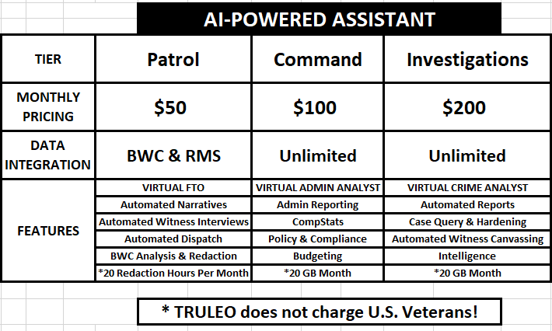

Appendix B –Terms & Fees

TERMS & FEES
Contract Duration | 12 months
Term Start Date | January 1, 2026
PATROL Licenses | 25 Officers X $50 X 12 Months = $15,000
COMMAND Licenses | 3 Command X $100 X 12 Months = $3,600
INVESTIGATION Licenses | 2 Investigation X $200 X 12 Months = $4,800
US VETERAN DISCOUNT | 3 Officers X $50 X 12 Months = ($1,800)  1 Command X $100 X 12 Months = ($1,200)  1 Investigations X $200 X 12 Months = ($2,400)
Total Annual Amount | $23,400 + ($5,400) = $18,000
Payment Terms | Net 30

Automatic Renewal. Upon the expiration of the original term, this agreement shall be automatically renewed for an additional three (3) year period unless, at least ninety (90) days prior to the expiration, either party gives the other party written notice of its intent not to continue the agreement. During any renewal term this agreement, the terms as set forth herein shall remain in effect unless modified in writing.

Appendix C – Support

1. MAINTENANCE AND SUPPORT SERVICES
TRULEO shall provide the following maintenance and support services inclusive of the Fees paid, including any bug fixes, patches, updates, and revisions. During the Term, TRULEO will also provide the Department with any updates to the Documentation.
TRULEO maintenance and support contact information is as follows:
Address: 140 Traction Street Greenville South Carolina 29611
Phone: (888) 991-3897
Email: support@TRULEO.co
2. SCOPE OF SUPPORT
Any defects shall be reported using the details below and any escalation necessary shall follow the escalation procedure set forth hereinafter. Reported defects may be classified by the Department as “Fatal”, “Material” or “Standard”.
TRULEO will provide assistance, help, and support, plus resolution of defects, via the following channels: Telephone Support
TRULEO shall maintain telephone support with "live" staff as a single point of contact to provide help with Department operation and support of the cloud services, the cloud application, or the Platform. TRULEO will immediately upon taking a telephone call reporting a defect, record full details of the defect in its issue tracking database and issue a tracking number to the Department. If the telephone support is unavailable, TRULEO will allow the Department to leave a message.
Remote Diagnostic Support
If requested by Department, TRULEO will provide remote diagnostic support as appropriate to resolve any defect.
Monitored Email Support
TRULEO will monitor incoming emails received at support@TRULEO.co reporting a defect, record full details of the defect in its issue tracking database, and issue a tracking number to the Department. TRULEO will respond within 24 business hours.
3. SUPPORT HOURS
Hours of Support
TRULEO shall provide telephone, remote, and email support 8 hours per day, each business day of the year excluding public holidays.
For any support request received during out-of-office hours, action will take place the next open business day.
09:00 to 17:00 EDT hours Monday to Friday

Appendix D – Success Contacts

 | Main Contacts
Name |  |  |  | Company Title |  | Email |  | Cell phone
Anthony Tassone |  |  |  | Co-founder & CEO |  | AT@truleo.co
Tejas Shastry |  |  |  | Co-founder & CTO |  | Tejas@truleo.co
PJ Tassone |  |  |  | Success Manger |  | PJ@Truleo.co

Appendix E – Insurance

TRULEO shall secure, prior to commencing any activities under this Agreement, and maintain, during the term of this Agreement, insurance coverage commensurate with applicable law as follows:
Workers’ Compensation Insurance and Employers Liability Insurance in an amount not less than $1,000,000.
Commercial General Liability Insurance, including coverage for Premises and Operations, Contractual Liability, Personal Injury Liability, Products/Completed Operations Liability, and Independent Contractor’s Liability (if applicable), in an amount not less than $4,000,000 annual aggregate, written on an on an occurrence form.
Automobile Liability Coverage including-as applicable-owned, non-owned, and hired autos, in an amount not less than $1,000,000, combined single limit.
Professional Liability Insurance, inclusive of cyber liability, in an amount not less than $2,000,000.

